
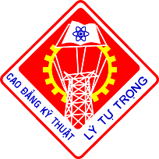
AGENDA
7:00 Check-in
8:00 Music Performance
8:40 - Flag-raising Ceremony
- Flower-offering Ceremony
to Ly Tu Trong Monument
- Statement of Reasons, Delegates Introduction
- Welcome speech on Vietnamese Teachers’ Day and Opening Ceremony
- Traditional Flag-giving Ceremony
- Drumming to begin new school year
- Speech from the student representative
- Reward and Scholarship Award
- Speech from Senior Leaders
10:20 Closing Ceremony

LY TU TRONG TECHNICAL COLLEGE
HO CHI MINH CITY
Cordially invites

To
The Vietnamese Teachers’ Day and
Opening Ceremony 2015 – 2016
Time: 8:00, November 19, 2015
Where: Ly Tu Trong Technical College HCMC
390 Hoang Van Thu, Ward 4, Tan Binh District
It would be a great honor to welcome you.
RECTOR
Dr. Pham Huu Loc

